Study of Memory in Psychology

by Saul McLeod published 2007, 2009
“Memory is the process of maintaining information over time.” (Matlin, 2005)
Memory is the term given to the structures and processes involved in the storage and subsequent retrieval of information. Memory is essential to all out lives. Without a memory of the past, we cannot operate in the present or think about the future. We would not be able to remember what we did yesterday, what we have done today or what we plan to do tomorrow. Without memory we could not learn anything. Memory is involved in processing vast amounts of information. This information takes many different forms, e.g. images, sounds or meaning. For psychologists the term memory covers three important aspects of information processing:
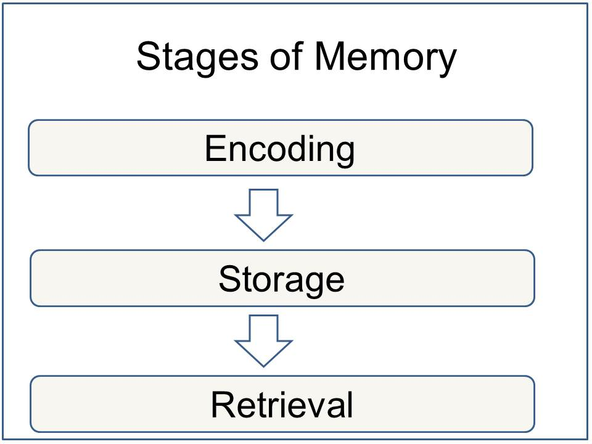

1. Encoding and Memory
When information comes into our memory system (from sensory input), it needs to be changed into a form that the system can cope with, so that it can be stored. (Think of this as similar to changing your money into a different currency when you travel from one country to another). For example, a word which is seen (on the whiteboard) may be stored if it is changed (encoded) into a sound or a meaning (i.e. semantic processing). There are three main ways in which information can be encoded (changed):
1. Visual (picture)
2. Acoustic (sound)
3. Semantic (meaning)
For example, how do you remember a telephone number you have looked up in the phone book? If you can see it then you are using visual coding, but if you are repeating it to yourself you are using acoustic coding (by sound). Evidence suggests that this is the principle coding system in short term memory (STM) is acoustic coding. When a person is presented with a list of numbers and letters, they will try to hold them in STM by rehearsing them (verbally). Rehearsal is a verbal process regardless of whether the list of items is presented acoustically (someone reads them out), or visually (on a sheet of paper). The principle encoding system in long term memory (LTM) appears to be semantic coding (by meaning). However, information in LTM can also be coded both visually and acoustically.
Some memories are explicit and are stored through effortful processing while others are implicit and are stored automatically.

2. Storage and Memory
This concerns the nature of memory stores, i.e. where the information is stored, how long the memory lasts for (duration), how much can be stored at any time (capacity) and what kind of information is held. The way we store information affects the way we retrieve it. There has been a significant amount of research regarding the differences between Short Term Memory (STM ) and Long Term Memory (LTM). Most adults can store between 5 and 9 items in their short-term memory. Miller put this idea forward and he called it the magic number 7. He thought that short-term memory capacity was 7 (plus or minus 2) items because it only had a certain number of “slots” in which items could be stored. However, Miller didn’t specify the amount of information that can be held in each slot. Indeed, if we can “chunk” information together we can store a lot more information in our short-term memory. In contrast the capacity of LTM is thought to be unlimited. Information can only be stored for a brief duration in STM (0-30 seconds), but LTM can last a lifetime.

3. Retrieval and Memory
This refers to getting information out storage. If we can’t remember something, it may be because we are unable to retrieve it. When we are asked to retrieve something from memory, the differences between STM and LTM become very clear.
STM is stored and retrieved sequentially. For example, if a group of participants are given a list of words to remember, and then asked to recall the fourth word on the list, participants go through the list in the order they heard it in order to retrieve the information.
LTM is stored and retrieved by association. This is why you can remember what you went upstairs for if you go back to the room where you first thought about it.
Organizing information can help aid retrieval. You can organize information in sequences (such as alphabetically, by size or by time). Imagine a patient being discharged form hospital whose treatment involved taking various pills at various times, changing their dressing and doing exercises. If the doctor gives these instructions in the order which they must be carried out throughout the day (i.e. in sequence of time), this will help the patient remember them.

Sensory Memory

These are the fleeting, immediate recordings of sensory information in the memory system
Iconic memory is a sensory memory of a visual stimuli; a photographic image memory lasting no longer than a few tenths of a second. Echoic memory is a momentary sensory memory of auditory stimuli; if attention is elsewhere, sounds and words can be recalled within 3 or 4 seconds.

Short Term Memory
Short term memory has three key aspects:
1. limited capacity (only about 7 items can be stored at a time)
2. limited duration (storage is very fragile and information can be lost with distraction or passage of time)
3. encoding (primarily acoustic, even translating visual information into sounds).
There are two ways in which capacity is tested, one being span, the other being recency effect.
Miller’s (1956) Magic number 7 (plus or minus two) provides evidence for the capacity of short term memory. Most adults can store between 5 and 9 items in their short-term memory. This idea was put forward by Miller (1956) and he called it the magic number 7. He though that short term memory could hold 7 (plus or minus 2 items) because it only had a certain number of “slots” in which items could be stored. However, Miller didn’t specify the amount of information that can be held in each slot. Indeed, if we can “chunk” information together we can store a lot more information in our short term memory. Miller’s theory is supported by evidence from various studies, such as Jacobs (1887). He used the digit span test with every letter in the alphabet and numbers apart from “w” and “7” because they had two syllables. He found out that people find it easier to recall numbers rather than letters. The average span for letters was 7.3 and for numbers it was 9.3.
The duration of short term memory seems to be between 15 and 30 seconds, according to Atkinson and Shiffrin (1971). Items can be kept in short term memory by repeating them verbally (acoustic encoding), a process known as rehearsal. Using a technique called the Brown-Peterson technique which prevents the possibility of retrieval by having participants count backwards in 3s, Peterson and Peterson 1959 showed that the longer the delay, the less information is recalled. The rapid loss of information from memory when rehearsal is prevented is taken as an indication of short term memory having a limited duration.
Baddeley and Hitch (1974) have developed an alternative model of short-term memory which they call working memory. Working Memory: a newer understanding of short-term memory that focuses on conscious, active processing of incoming auditory and visual-spatial information, and of information retrieved from long-term memory.

Long Term Memory
Theoretically, the capacity of long term memory could be unlimited, the main constraint on recall being accessibility rather than availability.
Duration might be a few minutes or a lifetime. Suggested encoding modes are semantic (meaning) and visual (pictorial) in the main but can be acoustic also.
Bahrick et al (1975) investigated what they called very long term memory (VLTM). Nearly 400 participants aged 17 – 74 were tested. There were various tests including: A free recall test, where participants tried to remember names of people in a graduate class. A photo recognition test, consisting of 50 pictures. A name recognition test for ex-school friends. Participants who were tested within 15 years of graduation were about 90% accurate in identifying names and faces. After 48 years they were accurate 80% for verbal and 70% visual. Free recall was worse. After 15 years it was 60% and after 48 years it was 30% accurate.
One of the earliest and most influential distinctions was proposed by Tulving (1972). He proposed a distinction between episodic, semantic and procedural memory.
- Procedural memory is a part of the long-term memory is responsible for knowing how to do things, i.e. memory of motor skills. It does not involve conscious (i.e. it’s unconscious - automatic) thought is not declarative. For example, procedural memory would involve knowledge of how to ride a bicycle.
- Semantic memory is a part of the long-term memory responsible for storing information about the world. This includes knowledge about the meaning of words, as well as general knowledge. For example, London is the capital of England. It involves conscious thought and is declarative.
- Episodic memory is a part of the long-term memory responsible for storing information about events (i.e. episodes) that we have experienced in out lives. It involves conscious thought and is declarative. An example would be a memory of our 1st day at school.
Cohen and Squire (1980) drew a distinction between declarative knowledge and procedural knowledge. Procedural knowledge involves “knowing how” to do things. It included skills, such as “knowing how” to playing the piano, ride a bike; tie your shoes and other motor skills. It does not involve conscious (i.e. automatic) thought. For example, we brush our teeth with little or no awareness of the skills involved.
Whereas, declarative knowledge involves “knowing that”, for example London is the capital of England, zebras are animals, your mums birthday etc. Recalling information from declarative memory involves some degree of conscious effort – information is consciously brought to mind and “declared”.
The knowledge that we hold in semantic and episodic memories focuses on “knowing that” something is the case (i.e. declarative). For example, we might have a semantic memory for knowing that Paris is the capital of France, and we might have an episodic memory for knowing that we caught the bus to college today.
Evidence for the distinction between declarative and procedural memory has come from research on patients with amnesia. Typically, amnesic patients have great difficulty in retaining episodic and semantic information following the onset of amnesia. Their memory for events and knowledge acquired before the onset of the condition tends to remain intact, but they can’t store new episodic or semantic memories. In other words, it appears that their ability to retain declarative information is impaired.
However, their procedural memory appears to be largely unaffected. They can recall skills they have already learned (e.g. riding a bike) and acquire new skills (e.g. learning to drive).
Effortful Processing Strategies
Chunking: organizing items into familiar, manageable units; often occurs automatically
Mnemonics: memory aids, especially those techniques that use vivid imagery and organizational devices
Spacing Effect: the tendency for distributed study or practice to yield better long term retention than is achieved through massed study or practice
Testing Effect: enhanced memory after retrieving, rather than simply rereading information.
Hierarchies: dividing and subdividing broad concepts into narrower concepts and facts.

