Sleep and Dreams

Sleep is the periodic, natural loss of consciousness that theoretically serves several purposes evolutionarily speaking.
- It protects us from harm
- It helps us recuperate—restoring and repairing brain tissue
- It helps us restore and rebuild our memories from the day
- It feeds creative thinking
- It supports growth

Our wakefulness and sleep pattern is one of our body’s circadian rhythms, which are our body’s biological clocks. It is controlled by the suprachiasmatic nucleus in our hypothalamus. When our body sees light the SCN causes the pineal gland to adjust melatonin production, modifying our feelings of sleepiness.

While we are sleeping our brain and body activity goes through cycles of activity.

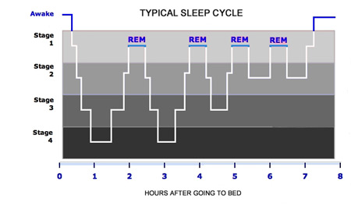

Stage 1 or REM/“Rapid Eye Movement” sleep is called this because your eyes are moving rapidly under your closed eyelids. Our most vivid dreams occur during REM sleep. This is also known as paradoxical sleep because our muscles are relaxed but other body systems are active.

Stages 2-4 or NREM sleep encompasses the rest of your sleep where brain activity slows

Brain waves
- Alpha waves—relatively slow brain waves of relaxed, awake state
- Beta waves—waves of an alert, waking state
- Delta waves—large, slow brain waves associated with deep sleep

Common Sleep Disorders
- Insomnia: Inability to fall asleep at will or at normal times
- Narcolepsy: The condition of falling asleep spontaneously and unwillfully
- Night terror or Pavor nocturnus or sleep terror disorder: abrupt awakening from sleep with behavior consistent with terror
- Periodic limb movement disorder (PLMD): Involuntary movement of arms and/or legs during sleep
- Rapid eye movement behavior disorder (RBD): Acting out violent or dramatic dreams while in REM sleep
- Restless leg syndrome (RLS): An irresistible urge to move legs while sleeping. Often accompanies PLMD.
- Sleep apnea: The obstruction of the airway during sleep
- Sleep paralysis: Conscious paralysis upon waking or falling asleep
- Sleepwalking or somnambulism: Engaging in activities that are normally associated with wakefulness (such as eating or dressing), which may include walking, without the conscious knowledge of the subject
Theories on the purpose of dreams
- A component and form of memory processing, aiding in the consolidation of learning and short-term memory to long-term memory storage.
- An extension of waking consciousness, reflecting the experiences of waking life.
- A means by which the mind works through difficult, complicated, unsettling thoughts, emotions, and experiences, to achieve psychological and emotional balance.
- The brain responding to biochemical changes and electrical impulses that occur during sleep.
- A form of consciousness that unites past, present and future in processing information from the first two, and preparing for the third.
- A protective act by the brain to prepare itself to face threats, dangers and challenges.

